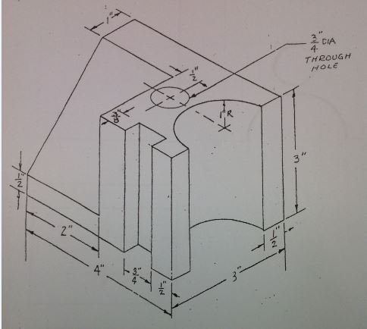

Please:  
Recreate this image in your cad program.  
You do not have to draw in the dimensions.